

DEPARTMENT OF COMPUTER SCIENCE

# MDS411

# DATA DRIVEN VISUALIZATION AND MODELING

### CAC 2

### CASE STUDY ASSIGNMENT

Topic

## Bengaluru in Motion: A Comprehensive Analysis of Traffic, Safety, Sustainability, and Infrastructure Impact

The Team,

Aan Maria James - 2348401

Angeline A - 2348409

Blessy Louis - 2348416

Karina Sebastain - 2348433

# ABSTRACT

In the backdrop of rising urbanization in Bengaluru, the need for a well-organized management of its traffic, road safety, sustainability, and infrastructure as never been more crucial. The objective of this project, **Bengaluru in Motion: A Holistic Analysis of Traffic, Safety, Sustainability, and Infrastructure Impact ,** is to analyze the urban problems of the city by approaching them in a wholesome manner through data visualization with Tableau. The project shall avail the transportation authority, urban planners, and policymakers with insights through real-time analysis of traffic patterns, incidents on roads, environmental impact, and infrastructure activity to develop a more livable and sustainable city. The traffic flow and congestion analysis dashboard visualizes the key patterns of traffic volume and speed variations in Bengaluru, locating congestion hotspots and helping in its improvement. The road safety dashboard develops the relations between traffic density, incident reporting, and the use of road capacity in order to enable authorities to understand where hotspots are located and how to effectively prioritize safety interventions. Additionally, the project focuses on sustainable transportation by highlighting the relationship between the use of public transportation, traffic flow, and environmental impact. Finally, the analysis of infrastructure and roadwork impacts gives insight into the ways ongoing construction activities affect the traffic dynamics and urban mobility. The comprehensive analysis herein after attempts to steer clear data-driven decisions to attain optimized urban mobility, public safety, and sustainable development in one of India's fastest-growing cities.

# CONTENT

|  |  |  |
| --- | --- | --- |
| **SI NO.** | **TITLE** | **PAGE NO.** |
| 1 | Introduction | 04 |
| 2 | Tableau | 07 |
| 3 | Dataset Preview | 08 |
| 4 | Approach | 11 |
| 5 | Result And Analysis | 28 |
| 6 | Conclusions | 30 |

# INTRODUCTION

Increasing urban mobility is growing as the most challenging issue to be dealt with for rapidly expanding metropolises across the globe. A city's growth automatically ensures that traffic congestion, road safety, environmental degradation, and infrastructural damage are more difficult to handle. No exception to this trend is Bengaluru-the major metropolitan hub in India. The city, popularly known as the Silicon Valley of India, has grown unprecedentedly in population as well as in infrastructure needs. The negative externalities include severe traffic congestion, increased accident rates, and environmental deterioration. It is here that smart city initiatives will play a crucial role in harnessing data and technology to bring efficient, safe, and sustainable urban environments.

The objective of this project is related to traffic management, road safety, sustainability, and infrastructure for improvement in an urban cityscape like Bengaluru by clearly illustrating the interrelationship of these factors with each other using a few advanced visualizations in Tableau. This actionable insight from the study will help city officials, policy framers, and transport planners.

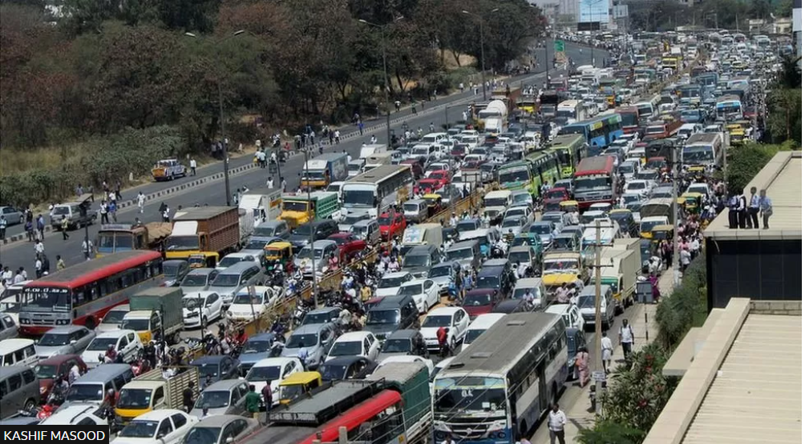

**Problem Statement**

Excessive traffic congestion, road incidents, and environmental degradation have long plagued Bengaluru because of its transportation system. The traffic burden increases day by day with the growth of population and the numbers of vehicles on the road. Traffic congestion at rush hours is excessively prolonging the travel time and therefore eating into the overall productive time of workers in this city. While this happens, the concern for road safety also increases because high volumes of traffic on the roads will lead to a higher rate of accidents. In addition, degradation of the environment resulting from vehicle emissions continues to mount as the air gets more and more polluted and climate change worsens.

These issues are further aggravated by constant infrastructure projects, such as roadwork and construction processes, which further fragment the flow of traffic as well as road capacity. The lack of insight from real-time data regarding traffic, safety, and infrastructure impacts hampers authorities in effective planning and successful implementation.

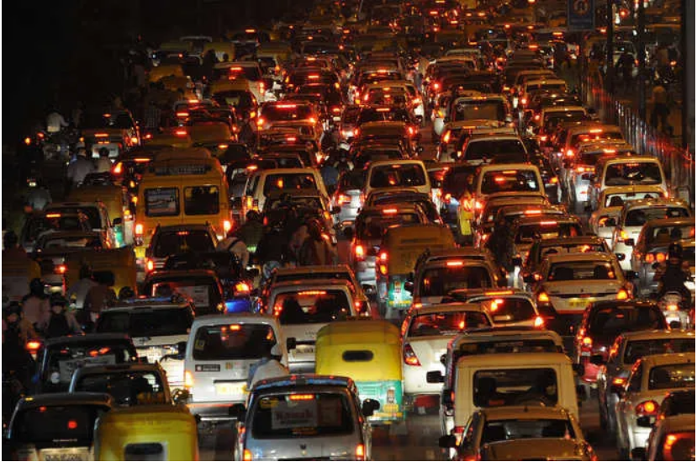

**Objective**

The objective of this project is to provide an overall data-driven analysis with respect to traffic flow, road safety, sustainability, and infrastructure in Bengaluru. The project aims to provide some key insights on the emerging traffic trends, incidents of safety, and their environmental impacts caused by the transport ecosystem of a city through dynamic visualizations using Tableau. These kinds of insights will help the city planners, authorities, and policymakers in making informed decisions for improving the flow of traffic, reduction in accidents, promotion of sustainable transport solutions, thereby minimizing disruptions that are caused by projects of infrastructure systems.

Objectives

1.Congestion Hotspots: Volume of traffic and congestion hotspots mapping across main intersections and locations in Bengaluru to understand the most affected regions.

2. Road Safety Data Analysis: Study the correlation between volume of traffic and road incidents, with a particular focus on areas with the highest accident rates for safety interventions.

3. Analyze Environmental Impact: Relate how congestion causes environmental degradation through the use of vehicles in different areas of the city, relating vehicle usage to the amount of pollution in those areas.

4. Analyze Infrastructure Impact: Examine the extent to which roadwork and infrastructure are affecting traffic carrying capacity, congestion, and road safety by developing a timeline of disruptions caused by construction.

**Target Audience**

This information is most suitably targeted at transportation authorities, urban planners, policymakers, and local government agencies tasked with the management of Bengaluru's urban environment. It also has value for environmental organizations and advocates of sustainability keen to understand the higher-order impact of transportation on the ecological footprint of the city. The aim of such a project will be interactive and data-driven in equipping such stakeholders with what they need to build more efficient, safer, and environmentally sustainable transportation networks.

# TABLEAU

Tableau is an incredibly powerful data visualization tool that will enable you to transform raw data into actionable insights through interactive, intuitive visual dashboards. It boasts an easy-to-use interface that provides great flexibility in connecting to a wide variety of data sources, including spreadsheets, databases, and cloud services for seamless data processing. It offers a range of visual elements-charts, graphs, maps, and tables-that can be customized for various needs of analysis. A unique selling proposition of Tableau is the ease with which it handles volumes of big data, in conjunction with real-time data analysis, which has been considered vital for decision-making in all industries. Furthermore, Tableau supports advanced analytical features, including predictive modeling, statistical analysis, and trend forecasting, thereby furthering insights on data. Its ability to integrate with other software platforms and export reports ensures that insights can be easily shared among teams and stakeholders.

The following project deals with the analysis and visualization of complex data, using Tableau, which has been generated in relation to traffic flow, road safety, sustainability, and infrastructure concerning Bengaluru. Tableau is used as a tool in interactive dashboards, creating capability for users to explore congestion levels, accident hotspots, and environmental impacts in real time. For example, heatmaps visualize traffic congestion across the entire city or different parts thereof, while line charts show changes in average speed throughout the day. The latter aspect of flexibility concerns integration with various sources of information: traffic reports, environmental sensors, and data of usage of public transportation. It empowers stakeholders such as urban planners by the usage of interactive filtering and dynamic visualizations, enabling one to zoom into an area of interest, assess trends, and then make decisions based on the data to improve traffic management and safety protocols within the city.

# DATASET PREVIEW

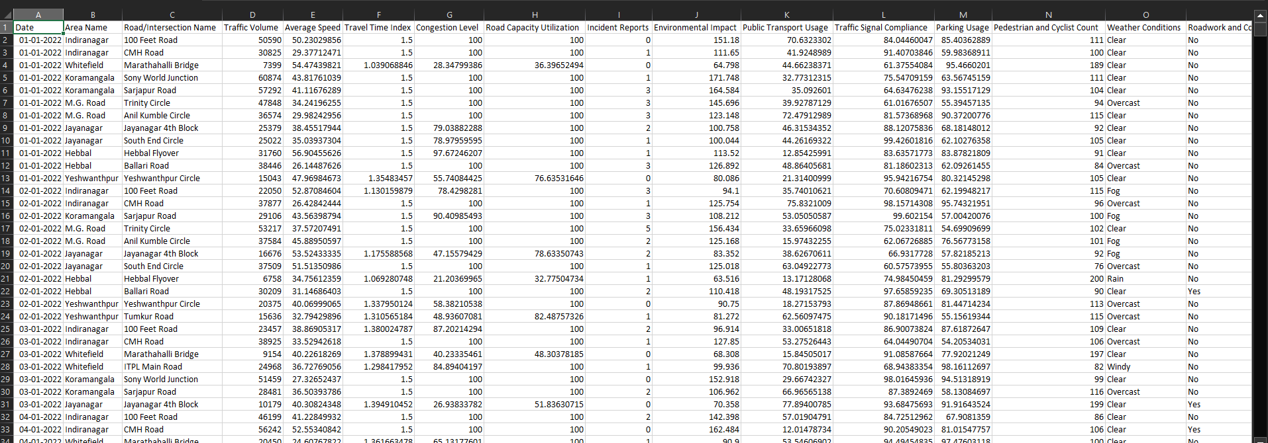

The dataset, sourced from Kaggle:

<https://www.kaggle.com/datasets/preethamgouda/banglore-city-traffic-dataset> , offers a multifaceted view of urban traffic dynamics and related factors within Bengaluru. This detailed dataset is structured to capture a wide range of variables influencing traffic conditions, safety, environmental impact, and infrastructure utilization. Here’s a thorough breakdown of each feature:

1.**Date:** This column denotes the exact date when the traffic data was recorded. The temporal dimension allows for trend analysis, seasonal variations, and patterns in traffic behavior over time. For instance, it helps in identifying peak traffic days, effects of public holidays, and other time-based patterns that might influence traffic volume and congestion.

2.**Area Name:** The dataset segments Bengaluru into distinct geographic areas. Each area represents a specific part of the city, allowing for localized analysis. This feature helps in identifying traffic patterns and issues that are specific to different neighborhoods or districts, making it easier to target interventions and improvements.

3.**Road/Intersection Name:** This feature specifies individual roads or intersections where the traffic data was captured. By focusing on specific locations, this column allows for detailed analysis of traffic conditions and incidents at precise points in the city's transportation network. This is crucial for pinpointing trouble spots and assessing the effectiveness of local traffic management measures.

4.**Traffic Volume:** This measure represents the number of vehicles that pass through a given road or intersection within a specific time frame, such as an hour or day. High traffic volume indicates heavy usage and can signal potential congestion issues. Analyzing traffic volume helps in understanding peak traffic times and the capacity requirements of different roads and intersections.

5.**Average Speed:** Average speed data provides insights into the flow of traffic on roads and intersections. It is calculated as the mean speed of all vehicles observed during the data collection period. Lower average speeds often correlate with higher congestion levels, whereas higher speeds indicate smoother traffic flow. This metric is essential for assessing how effectively traffic is moving through different parts of the city.

6.**Travel Time Index:** The Travel Time Index compares the average travel time on a road or intersection to what it would be under free-flow conditions (i.e., with no traffic). An index greater than 1 indicates that travel times are slower than optimal, highlighting congestion. This index is useful for understanding how traffic delays impact overall travel efficiency.

7.**Congestion Level**: This qualitative feature categorizes traffic congestion into levels such as low, moderate, or high. It provides a snapshot of traffic conditions in different areas, helping to quickly assess which areas are experiencing severe congestion and may require traffic management interventions.

8.**Road Capacity Utilization:** This feature measures how much of the road’s total capacity is being used. It is expressed as a percentage and helps in understanding whether roads are operating at, below, or above their designed capacity. High utilization rates can indicate potential bottlenecks and areas where infrastructure improvements may be needed.

9.**Incident Reports:** This column tracks the number of reported traffic incidents, including accidents, breakdowns, and other disruptions. Analyzing incident reports helps in identifying patterns related to high-incident areas, which can be used to enhance safety measures and improve road design.

10.**Environmental Impact**: This feature assesses the environmental consequences of traffic activities, such as emissions of pollutants and carbon footprint. Understanding the environmental impact is crucial for developing strategies to mitigate pollution and promote greener transportation options.

11.**Public Transport Usage**: This column measures how frequently public transport systems, such as buses and trains, are used. It provides insights into the effectiveness of public transportation in reducing traffic congestion and its role in providing alternatives to private vehicle use.

12.**Traffic Signal Compliance:** This feature tracks how well drivers adhere to traffic signals and rules. High compliance rates suggest effective traffic signal management, while lower rates might indicate issues with signal enforcement or driver behavior.

13.**Parking Usage:** Parking usage data shows the extent to which parking facilities are utilized. This feature helps in understanding parking demand and availability, which can influence decisions regarding parking management and urban planning.

14.**Pedestrian and Cyclist Count:** This column tracks the number of pedestrians and cyclists in various areas. It provides data on non-motorized transport modes and helps in evaluating their impact on traffic flow and road safety.

15.**Weather Conditions:** Weather data, including factors such as rainfall, fog, temperature, and visibility, is included to understand how different weather conditions affect traffic patterns and safety. Weather conditions can significantly impact driving behavior and traffic flow, making this data essential for comprehensive traffic analysis.

16.**Roadwork and Construction Activity**: This feature records ongoing roadwork and construction projects. It provides context for disruptions in traffic patterns and helps in assessing how construction activities impact traffic flow and road capacity.

Overall, this dataset offers a rich and detailed view of traffic dynamics and associated factors in Bengaluru, making it an invaluable resource for analyzing and improving urban transportation systems.

# APPROACH

## **DASHBOARD 1: Traffic Flow and Congestion Level Analysis**

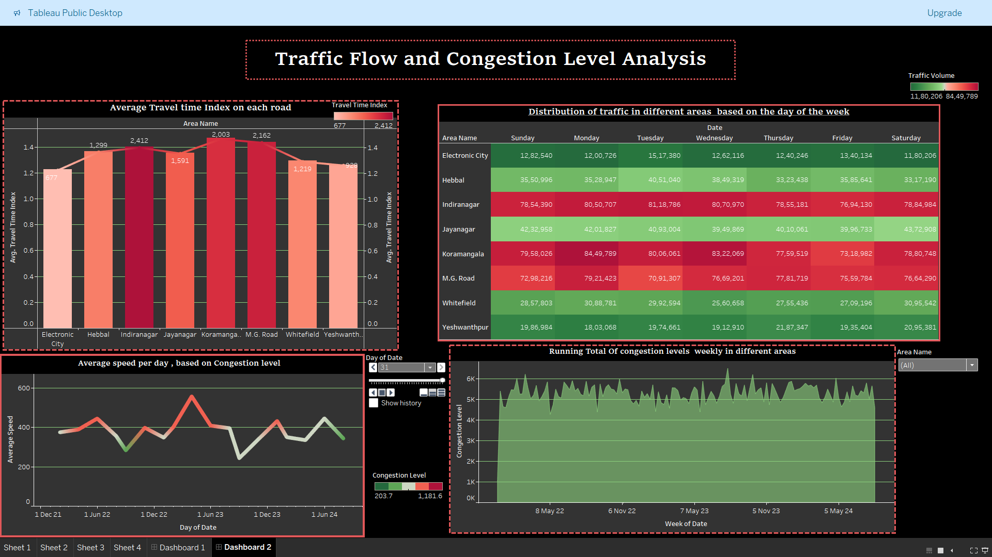

Figure 1 : Traffic flow and Congestion level Analysis dashboard

This "Traffic Flow and Congestion Level Analysis" dashboard represents an overall view of the urban traffic pattern, highlighting the key parameters of travel time, congestion, and speed variations regarding different areas and time intervals. These are combined into bar charts, heatmaps, and line graphs to offer daily and weekly insights into the condition of the traffic. It is an interactive dashboard that dynamically shows visualizations through animation and filters. These enable the view of traffic trends across a wide range of regions and time. This will be a very useful tool to make informed decisions by urban planners and traffic managers in the process of planning road efficiency and congestion management.

1.1 Average Travel Time Index on Each Road

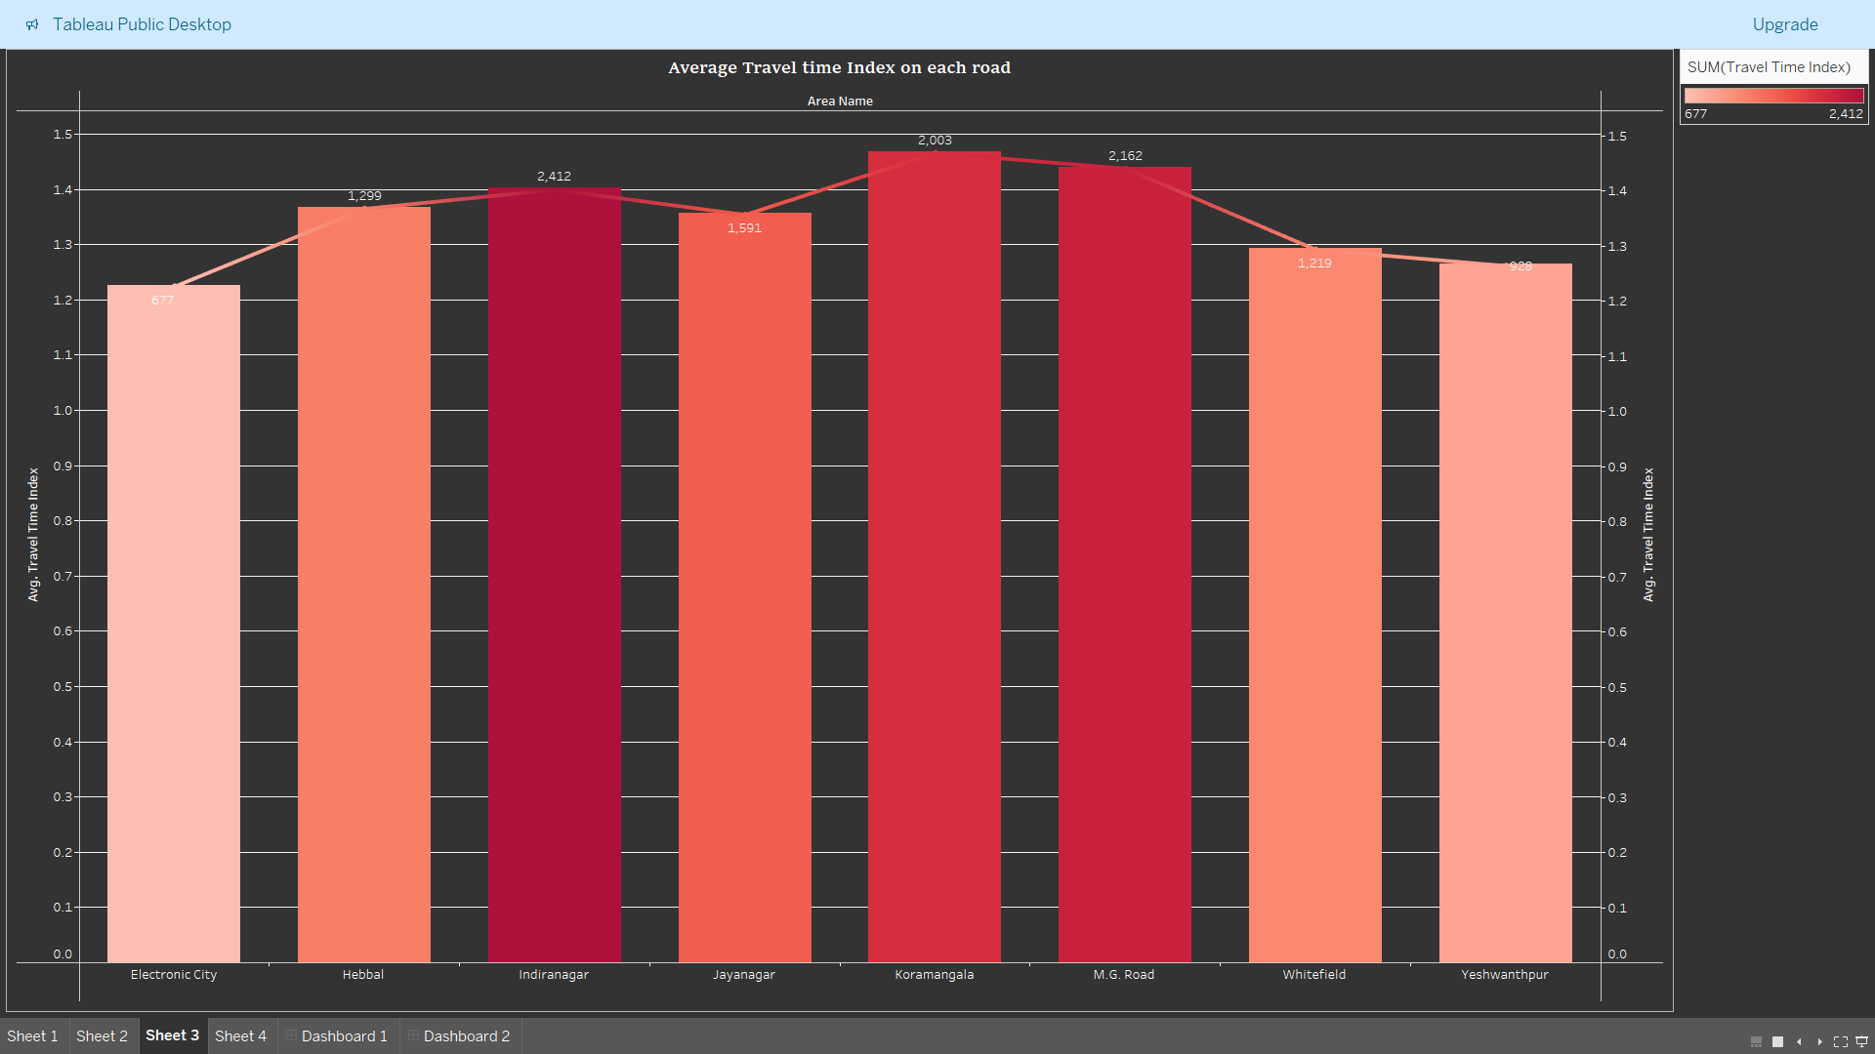

Figure 1.1 : Average Travel time index on each road

Bar diagram showing **average travel time index** for various areas, which can be used to understand the traffic delays on main roads. Regions like **Koramangala** and **Jayanaga**r have the highest travel time indices-2.162 and 2.003-respectively, which shows that they have high delays and congestion. **Electronic City** and **Yeshwanthpur** provide the minimum travel time indices, 0.677 and 0.928, respectively, which show easier traffic flow. The chart has been designed to visually compare travel delays as a means for exploring where traffic management interventions may be effective.

1.2 Distribution of Traffic in Different Areas Based on Day of the Week

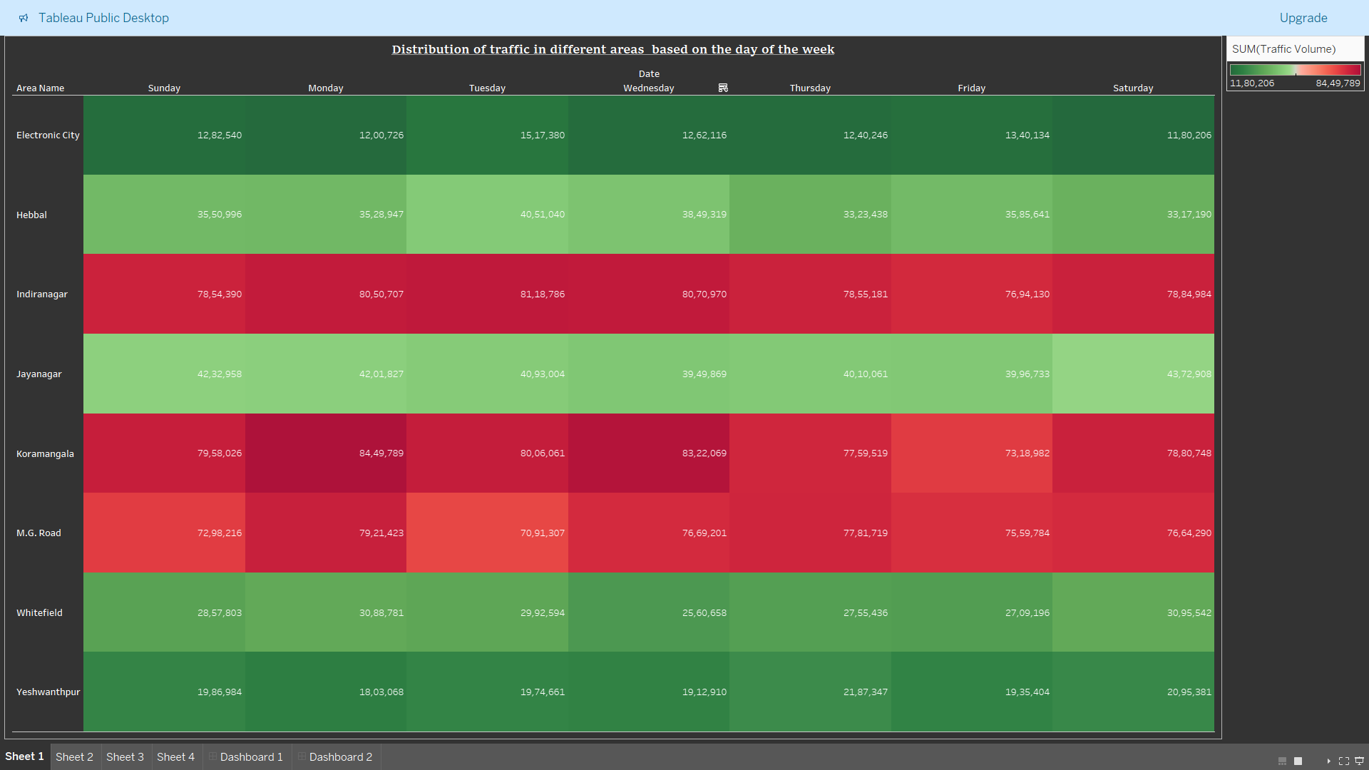

Figure 1.2 : Distribution of Traffic in Different Areas Based on Day of the Week

The heatmap above illustrates the volume of traffic across different areas on different days of the week. Color varies from green for low to red for high. Areas like **Indiranagar** receive extremely high volumes throughout the week, with volumes exceeding 80,00,000 on Monday and Tuesday. Such areas like **Jayanagar** and **Yeshwanthpu**r receive low traffic, peaking on certain days like Friday. This heat map shows the days of peak traffic, hence allowing urban planners to plan resources and interventions accordingly.

1.3 Average Speed per Day Depending on Congestion Level (Animation Graph)

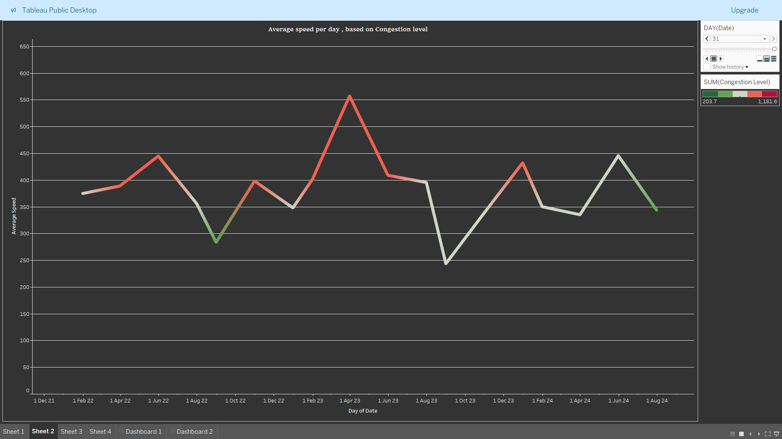

Figure 1.3 : Average Speed per Day Depending on Congestion Level (Animation Graph)

This line graph is prepared with an animation feature, showing how average speed changes by the congestion level day by day. The animation is actually based on the week number to provide dynamic insight into the fluctuation in traffic speed during the year. Peaks are days when congestion is low and speeds are higher; troughs indicate days where congestion is high and traffic moves slowly. This interactive visual enables viewing week-over-week changes in traffic speed to show, near real-time, exactly how road congestion is impacting the efficiency of travel.

1.4 Running Total of Congestion Levels per Week in Various Areas [Filterable by Area Name]

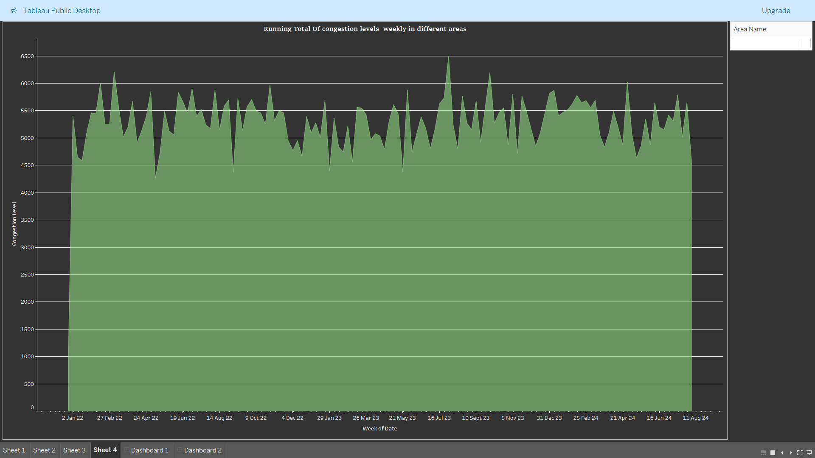

Figure 1.4: Running Total of Congestion Levels per Week in Various Areas [Filterable by Area Name]

This is an area graph showing the weekly running total of congestion levels across areas. The graph charts the long-term view of congestion accumulation over time, with noticeable spikes some weeks pointing to severe congestion. The graph is embedded with a **filter** by which congestion data from specific areas can be viewed. This they can only achieve by the use of a filter option in selecting an area they would wish to know how congestion trends evolve in over time. The graph is so customizable with a filter that users can zoom in on problem areas and then strategize a solution more appropriately, taking into consideration the unique needs of each region.

Overall, this is an immense combination of insights, animation, and interaction, which will allow urban planners and traffic managers to monitor, analyze, and react in real-time to the traffic patterns and achieve optimal congestion control and road infrastructure planning.

## **DASHBOARD 2: Road Safety and Incident Analysis**

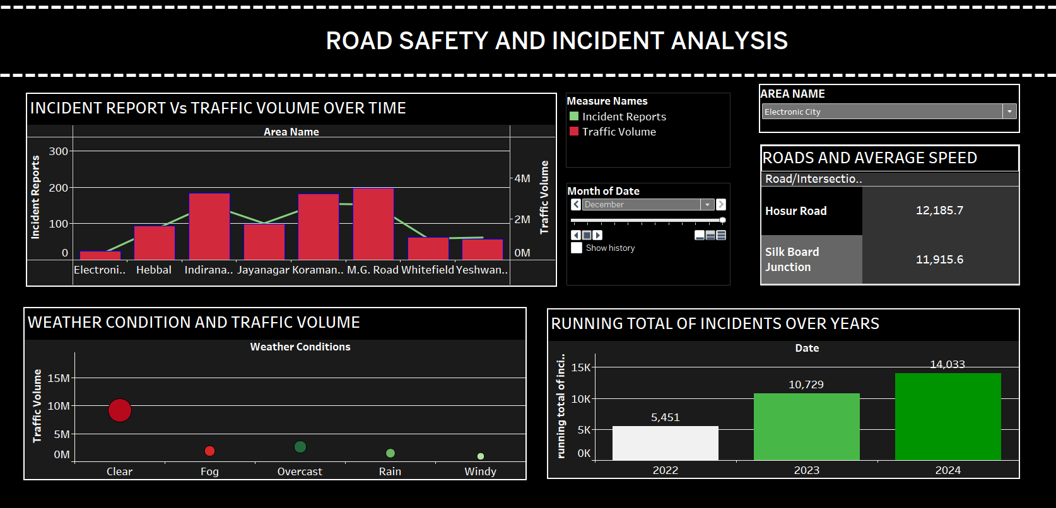

Fig 2: Road Safety and Incident Analysis

The Road Safety and Incident Analysis Dashboard provides a detailed overview of the condition of traffic flow, incidents reported, and other prevailing factors that enable safety agencies and local governments to focus on road safety. The visualizations combined in this dashboard aim to explore the correlation between traffic volume, weather conditions, and incident reports to identify areas of immediate concern that need to be improved. It offers the means of strategizing interventions more appropriately and aids in advancing the measures in place concerning road safety by highlighting relationships and correlations between incident rates, volume of traffic, weather conditions, and compliance levels.

**2.1 Dual Axis Bar and Line Chart depicting Incident Vs Traffic Volume over time**

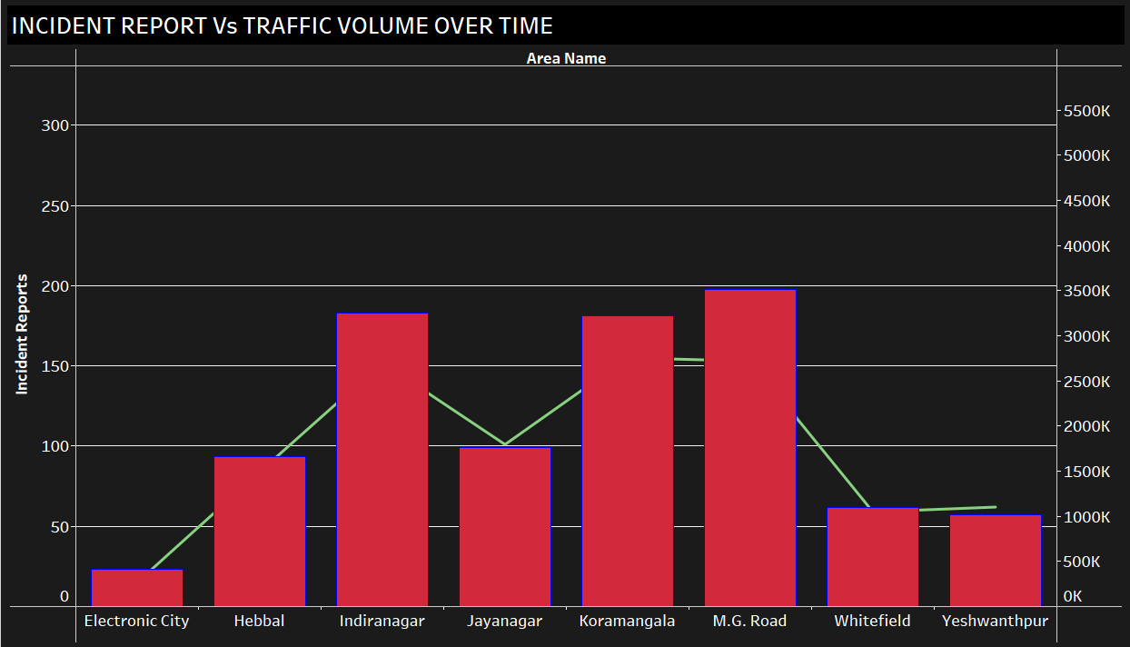

Fig 2.1 Incidents report Vs Traffic volume over time

This dual axis bar and line charts that changes over time show that the

Regions like Indiranagar and Koramangala depict a higher number of incident reports than others, though their traffic volume might vary. It was observed that Indiranagar has the highest number of incidents, and Koramangala is near its incidents, depicting these as high-risk areas.

From the chart, it seems that though traffic volume does affect incidents and higher volumes have more incidents, it's not the sole cause. For instance, Whitefield, which has a traffic volume of a middle level, shows lower incidents; hence, it could mean factors other than volumes may be in act, such as condition of roads or driver behavior.

**2.1 Road name and Average Speed based on Area name title card**

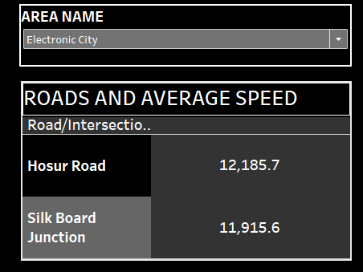

Fig 2.2 Roads and Average speed based on Area name

The table depicts the road name and average speed of the selected area, the roads such as Hosur Road and Silk Board Junction have an average speed of 12,185.7 and 11,915.6 respectively, which indicates that these roads would be less prone to traffic congestion but could be more prone to high speeds accidents. The higher the relative speed, the better is the road condition with fewer crossroads or junctions. High average speeds in areas need monitoring for incidents regarding speed, and the setting of speed limits in such areas may have to be reviewed in light of maintaining safety on roads.

**2.3 Weather Condition and traffic volume**

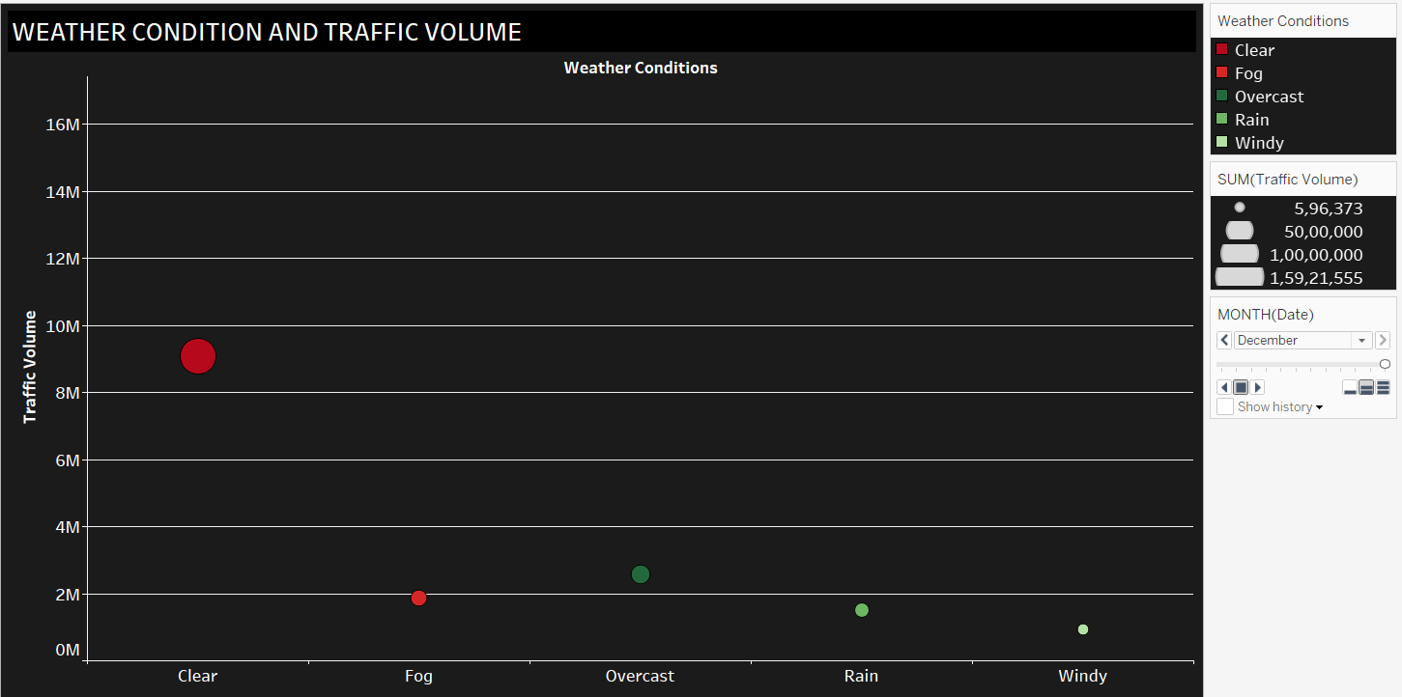

Figure 2.3 Weather condition and traffic volume

The scatter plot shows the best-weather condition holds the largest red bubble, while other categories of weather conditions, which include fog, overcast, rain, and windy conditions, have very small bubbles, indicating extremely smaller volumes of traffic during these conditions.

The amount of traffic in poor weather is lower, presumably due to people being more cautious or refraining from traveling in bad weather. This lower volume could, in fact, lower incident rates, once more bringing up the importance of traffic advisories when weather conditions are poor.

**2.4 Waterfall chart depicting Running total of incidents over years**

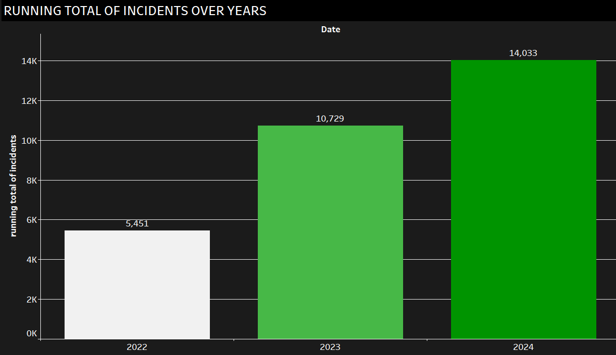

Fig 2.4 Running total of Incidents over years

The running total is growing from 5,451 in 2022, through 10,729 in 2023, up to 14,033 in 2024. This reflects an upward trend of incidents with an upward trajectory.

Annual Trend Analysis: Gradual increase in the number of cases over the years may be due to either increasing volume of traffic or deterioration of road conditions. Incidents, though under varying weather conditions, have one after another been on the rise, and this could denote an underlying problem like increased usage of vehicles, poor management, or lack of safety measures being implemented.

## **DASHBOARD 3: Sustainable Transport and Environmental Impact**

The "Sustainable Transport and Environmental Impact Dashboard" conveys pictorially significant factors in transport and their environmental impacts within Bengaluru. The visualization provides information to city planners on how public transport, non-motorized transport, and usage of roads influence environmental impact. Weather condition and time have been provided as filters for further information. Taken together, all these visual elements work to emphasize the various transport modes, road capacity, environmental sustainability, and pedestrian safety across different quarters of the city.

3.1 Public Transport Usage vs. Environmental Impact

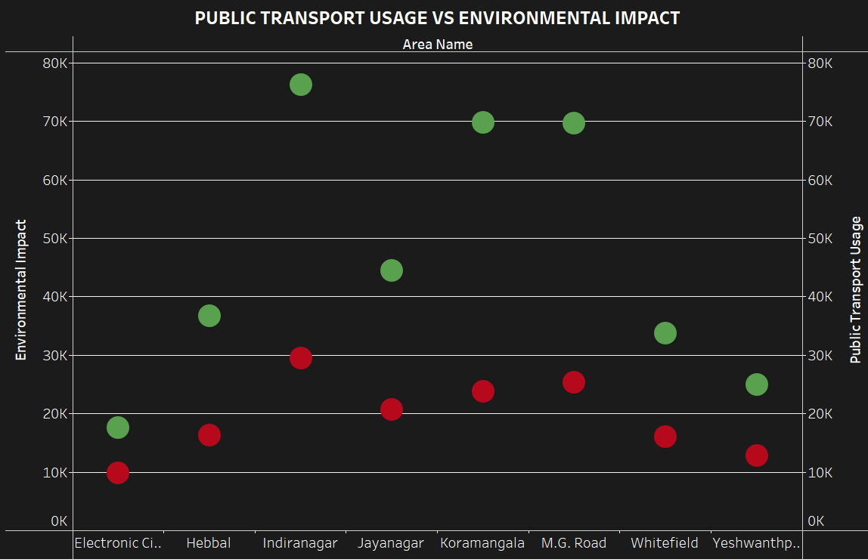

Fig 3.1 Public Transport vs Environmental Impact Graph

This scatter plot is a dual axis graph and compares the use of public transport versus the environmental impact in the diversity of areas in Bengaluru. The y-axis on the left hand side is the environmental impact while the y axis on the right hand side tells us about the Public Transport Usage, while the x-axis is area names. The bubbles vary in color and size, showing both public transport usage in green and environmental impact in red. It helps in decision-making by underlining regions with high utilization of public transport but high environmental impact, probably due to inefficiencies in the public transit systems or due to other causes of pollution in those regions.

3.2 Pedestrian and Cyclist Counts Combined with Weather Conditions (Map)

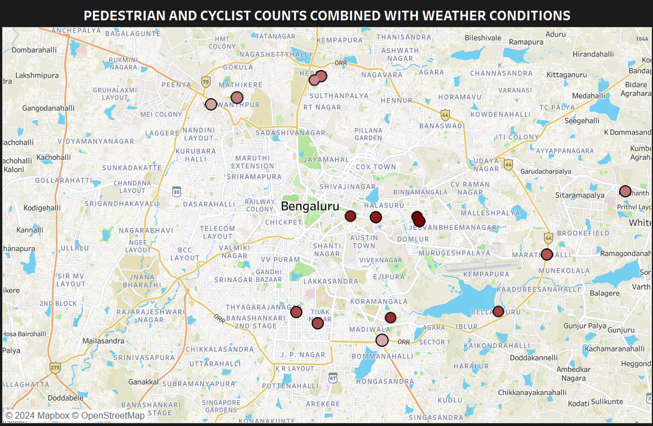

Fig 3.2 Pedestrian and Cyclist Counts with Weather conditions

This map displays pedestrian and cyclist counts across different areas of Bengaluru, with data points marked on the city map. The size and the colour of the circles represents the volume of pedestrian and cyclist traffic. There is an additional Filter option where you can choose the weather conditions in order to identify the volume of traffic with respect to each weather condition. This visualization helps understand how weather impacts the number of pedestrians and cyclists using non-motorized transport. For instance, smaller circles during rainy weather suggest a decrease in foot or cycle traffic, highlighting areas where infrastructure might need improvement for weather resilience.

3.3 Road Capacity Utilization Over Time

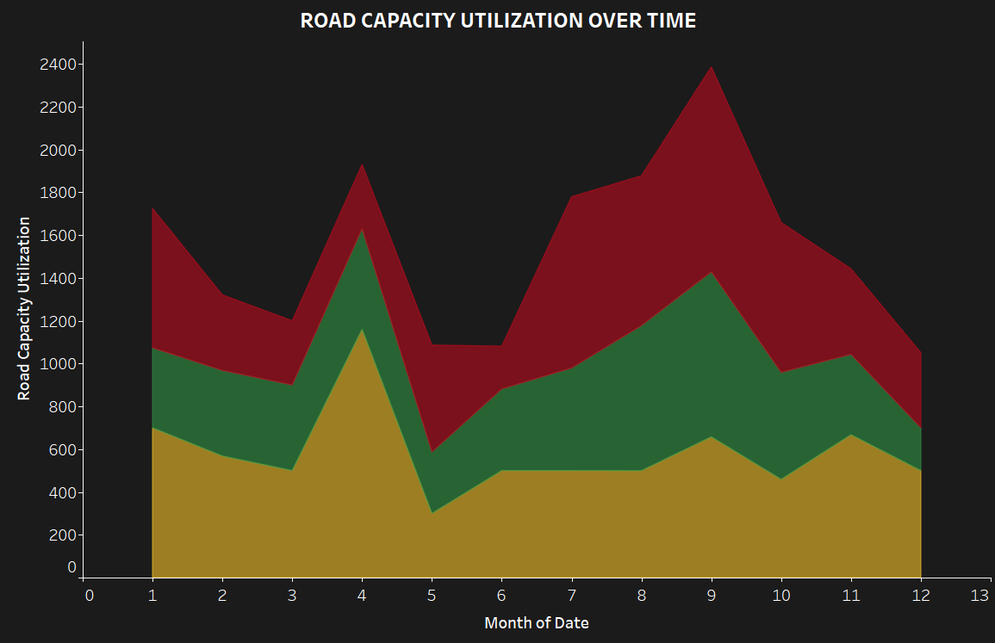

Fig 3.3 Road Capacity Utilization Area Graph

This area chart depicts the road capacity utilization across three prominent areas: Indiranagar, Koramangala, and M.G. Road. The road capacity utilization is shown on the y-axis, and time, month of the date, is shown on the x-axis. The different colored areas represent three locations and depict how these areas are managing the flow of traffic. This view presents the ongoing construction or other events that may cause changes in road capacity usage and points out areas where interventions will be necessary to mitigate congestion.

3.4 Mode of Transport Share (Donut Chart)

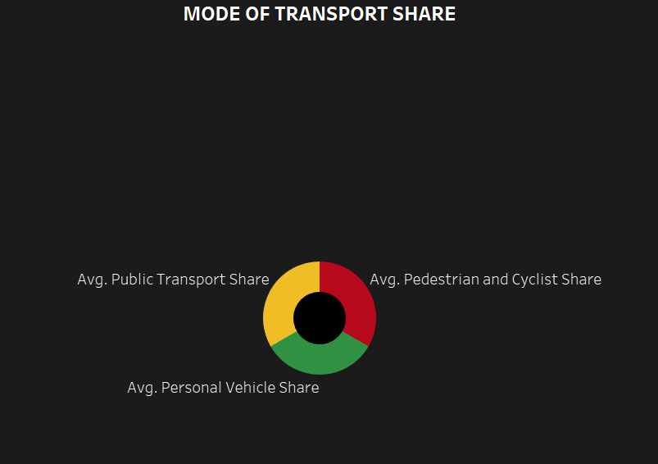

Fig 3.4: Mode of Transport Share(Donut Chart)

The contribution of different transport modes to Bengaluru is shown by the donut chart. The segments are representative of the share of usage: public transport in yellow, pedestrians and cyclists in red, and personal vehicles in green. This simple visualization helps in taking an at-once glimpse at which mode of transport is most utilized within the city and allows city planners to target their efforts in the promotion of underused sustainable transport methods like walking, cycling, or public transit.

This dashboard combines multiple data types to provide a holistic view of urban transportation and environmental factors, offering valuable insights for sustainable city planning.

## **DASHBOARD 4: Bangalore Traffic Volume Insights**

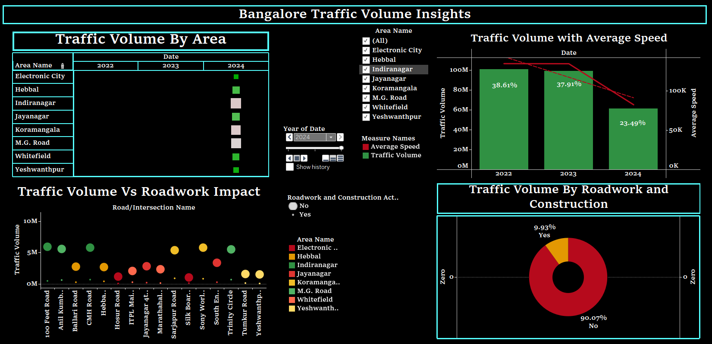

Fig 4: Bangalore Traffic Analysis Insights Dashboard

Fig 4: "Bangalore Traffic Analysis Insights" dashboard looks into the analysis of traffic volume over major areas in Bangalore from 2022 to 2024, underlining key areas such as Electronic City, Whitefield, and Koramangala. Looking at the chart "Traffic Volume with Average Speed", it reflects the downfall in both traffic volume and average speed for 2022 to 2024, which could reflect congestion. It can be seen from the scatter plot "Traffic Volume vs Roadwork Impact" that, out of these many roads, the impact of roadwork is witnessed mainly on busy roads like Hebbal and Hosur Road. The pie chart finally shows that 9.93% of the traffic is affected by roadwork and the remaining portion, 90.07%, remains unaffected. Overall, the road construction is influencing traffic flow in some areas.

4.1 Traffic Volume By Area

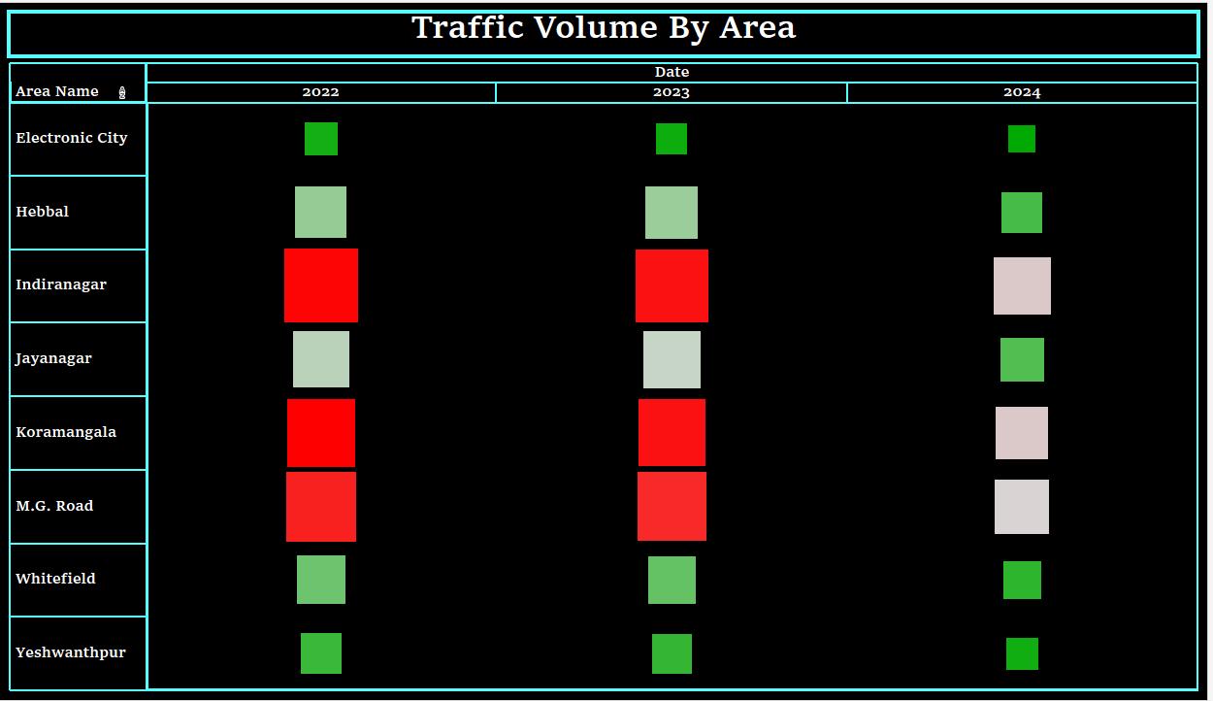

Fig 4.1: Traffic Volume By Area

Fig 4.1: "Traffic Volume by Area", shows the traffic trends from 2022 to 2024 across various areas of Bangalore. Red blocks reflect higher traffic volume, while green reflects lower volumes. For example, places like Indiranagar, Koramangala, and M.G. Road have big areas colored red for 2022 and 2023, indicating a high state of congestion. This starts to break by 2024 when these same places start to reflect more neutral and green blocks, indicating that this comparative rise in congestion has somewhat dissipated. This would mean that most likely, traffic flow must have streamlined due either to infrastructural changes or some new management measures being taken over the roads.

4.2 Traffic Volume Vs Roadwork Impact

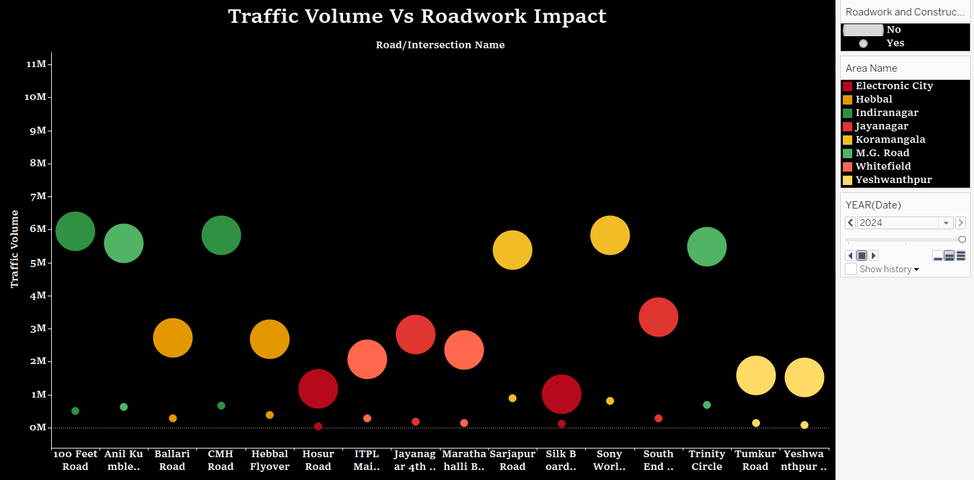

Fig 4.2: Traffic Volume Vs Roadwork Impact

Fig 4.2: “Traffic Volume Vs Roadwork Impact” visualizes the association between traffic volume and the impact of roadwork on different roads or intersections over time. It offers a date-based animation feature. The vertical axis is the traffic volume in millions, and the horizontal axis represents different roads or intersections. Size mapping for every circle is done by traffic volume, and color mapping by area name, such as Electronic City, Hebbal, and Indiranagar. This uses a date filter in the "Pages" shelf to animate changes in volume and roadwork impact from 2022 to 2024. Further, filtering roads with and without the presence of roadwork impact can be selected. Traffic flow habits for these varied regions are dynamic with how roadwork and constructions affect them.

4.3 Traffic Volume with Average Speed

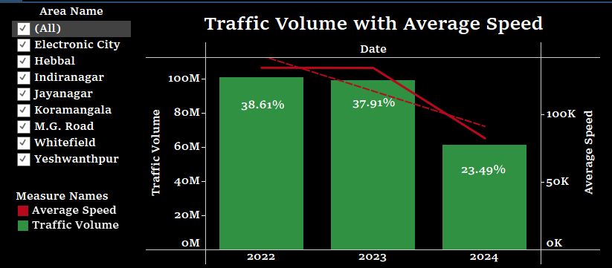

Fig 4.3: Traffic Volume With Average Speed

Fig 4.3: “Traffic Volume with Average Speed shows the traffic volume and average speed from 2022 to 2024. The volume is trending downwards, starting from around 100 million in 2022 to approximately 50 million in 2024, at a year-over-year decrease of 38.61% for 2022 and 23.49% for 2024. Meanwhile, in the same period, the average speed, depicted by the red line in the graph, has also decreased, hence reflecting poorer conditions than the reduced volume would suggest. This might suggest that congestion is not solely volume-related but could also be influenced by more infrastructural changes, such as those in the road conditions.

4.4 Traffic Volume By Roadwork and Construction:  
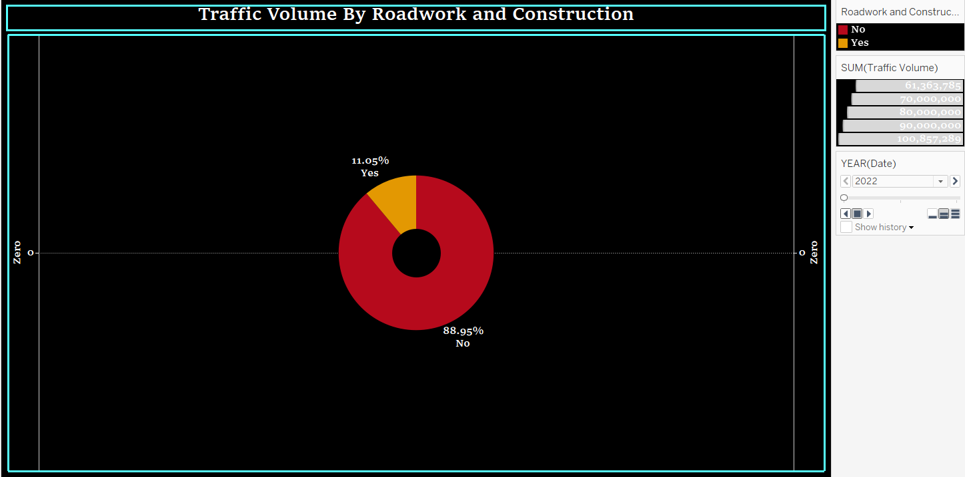

Fig 4.4: Traffic Volume By Roadwork and Construction

Fig 4.4: “Traffic Volume By Roadwork and Construction” clear relation of traffic volume and roadwork or construction can easily be differentiated starting from 2022 until 2024. In the year 2022, 88.95% of the volume of traffic was on roads with roadwork, indicating major construction activity impinging on traffic. The percentages of traffic volume over the roads with road work in 2023 and 2024 fell precipitously to 8.96% and 9.93%, respectively. That would most likely suggest that roadwork became less influential in traffic volume, and large-scale construction projects were either completed or moved elsewhere, thus causing fewer disruptions by roadworks in more recent years.

Overall, In the "Bangalore Traffic Analysis Insights" dashboard, it is noticed that the volume of traffic and average speed reduced from 2022 to 2024 due to the impact brought by roadwork on major roads such as Hebbal and Hosur Road. This is representative of the fact that in 2024, these effects of roadwork were greatly reduced, therefore showing the end or effective handling of projects. The trend of congestion starts to rise and then eases off by the year 2024 for major locations.

# RESULT AND ANALYSIS

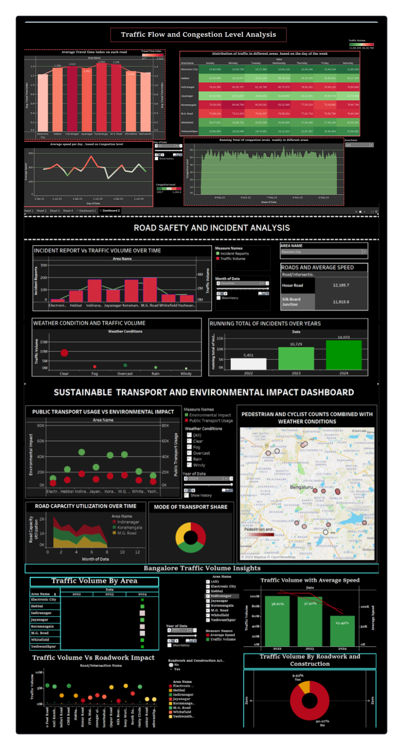

Figure 5: Overall Analysis of Bengaluru Traffic

This Traffic Analysis Dashboard provides a detailed, comprehensive view of flow traffic, congestion levels, incidents about road safety, and environmental impact caused by public transport in Bangalore. It visualizes multiple metrics, providing a multidimensional overview of how the diverse variables-like average travel times, traffic volumes, incident reporting, weather, and public transport flows-affect urban mobility. It is divided into four main parts: Traffic Flow and Congestion Level Analysis, Road Safety and Incident Analysis, Sustainable Transport and Environmental Impact, and finally, Traffic Volume Insights. The sheets are expected to drive decisions at the level of city planners, policymakers, and transport authorities on how to advance traffic management and ensure sustainable transport.

Traffic Flow and Congestion Level Analysis: This section includes key indicators that explain the flow of traffic congestion on major roads. The average travel time index for each road is plotted as a bar graph. The chart shows the highest congestion in peak hours faced by M.G. Road and Koramangala. The heatmap gives information on the pattern of traffic in various areas on different days of the week. It highlights that the volume of traffic is always higher during the weekdays, that is, from Monday to Friday. Also, the congestion level versus average speed line graph shows a sharp decline in speed during peak traffic hours in most areas, showing severe congestion in some areas.

The "Road Safety and Incident Analysis" elaborates on how the volume of traffic applies to road incidents. Indeed, according to the bar chart, a higher volume of traffic definitely relates to more incidents throughout most areas of M.G. Road and Whitefield. The dashboard also presents a bubble chart to analyze the effect of weather conditions on traffic volume, where rain and fog decrease the volume of traffic but increase the rate of accidents. Running Total over Incidents over Years: The running total number of incidents over the years has shown an increase in road incidents, with a sharp increase in the year 2024, which means more safety measures should be involved.

The "Sustainable Transport and Environmental Impact" dashboard focuses on the environmental dividend of using public transport. The following scatter plot shows a positive correlation between increased public transport usage and reduced environmental impact. Again, localities like Koramangala and Indiranagar lead the fray in this respect. A pie chart of the dominance of private vehicle usage in transport still predominates, yet opens up opportunities to shift further towards more sustainable modes of transport once public transportation is better developed. Visualizing pedestrian and cyclist counts as seen on this map may be affected by meteorological conditions in the use of non-motorized transport.

Finally, the "Bangalore Traffic Volume Insights" section gives the overview of the traffic volumes throughout the years, showing how the roadwork and construction have impacted traffic volumes in main areas. The bar chart covers traffic volume for the years 2022-2024 and displays an evident increase at Whitefield, Electronic City, and Hebbal. Another finding of interest involves the relation between roadwork and average speed; traffic speed seriously decreases in locations with road construction. This accentuates the need for better planning of infrastructure projects on the road network, considering their consequences for the overall efficiency of flow.

# CONCLUSION

The overall conclusion of this traffic flow and congestion analysis project is that Bangalore's urban transport system faces immense pressure due to escalating congestion, rising road incidents, and growing environmental concerns. This dashboard adds high value to this insight in presenting the city's prevailing traffic trends, besides depicting areas with intense traffic density, congestion trends, and what causes delays, such as roadwork and construction. Certain roads, like M.G. It ranges from a very high congestion level, as recorded in the case of Road, Whitefield, and Koramangala, that are turning out to be the congestion bottles affecting both average travel times and vehicle speeds, thus requiring an immediate targeted intervention.

One important observation that comes out is relating to the relationship between the congestions in traffic flow and road safety incidents. Chances of accidents go up when the volume of traffic increases, more so in densely populated urban areas. These risks are further enhanced by the weather conditions of rain and fog due to reduced visibility, making driving more hazardous. The growing trend of the incidents within these years, especially in 2024, underlines the need to strengthen the police in enforcing road safety, improving road infrastructure, and enhancing electronic traffic management systems to prevent accidents and guarantee safer flow on the roads.

Another important aspect of the project is environmental. It lists public transportation as the reason for lower environmental impact in urban mobility. Areas like Indiranagar and Koramangala, being areas where the usage of public transport is greater, show a significant drop in environmental footprint, thereby indicating an extension and improvement in the same can bring certain benefits. At the same time, data indicates continuing reliance on private modes of transport as well, adding to the congestion and pollution in traffic. A shift to public transport and non-motorized modes of commute, such as cycling and walking, is necessary for sustainable urban development, through better infrastructure and incentives.

Finally, the analysis points toward the high effect of roadwork or construction works on traffic flow. The average speeds are much lower in areas with roadwork; thus, areas with roadwork congestion need to plan for such projects much better. Traffic disruption by construction can be minimized or diverted by proper scheduling, public relations, and detours. In a nutshell, the given project covers a wide overview of the traffic in Bangalore and presents some data-driven insights on how congestion can be addressed together with road safety and efficient sustainable transport solutions for the future.